Lab - Design and Implement a VLSM Addressing Scheme

# Topology

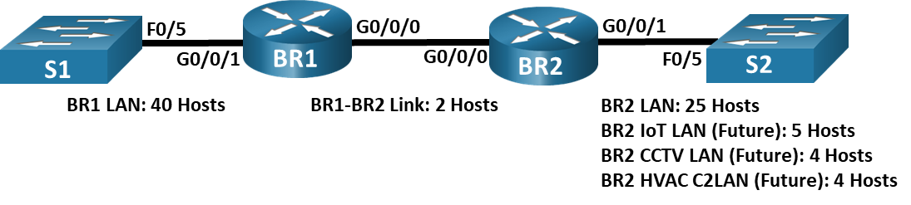

# Objectives

Part 1: Examine Network Requirements

Part 2: Design the VLSM Address Scheme

Part 3: Cable and Configure the IPv4 Network

# Background / Scenario

Variable Length Subnet Mask (VLSM) was designed to avoid wasting IP addresses. With VLSM, a network is subnetted and then re-subnetted. This process can be repeated multiple times to create subnets of various sizes based on the number of hosts required in each subnet. Effective use of VLSM requires address planning.

In this lab, use the 192.168.33.128/25 network address to develop an address scheme for the network displayed in the topology diagram. VLSM is used to meet the IPv4 addressing requirements. After you have designed the VLSM address scheme, you will configure the interfaces on the routers with the appropriate IP address information. The future LANS at BR2 will need to have addresses allocated, but no interfaces will be configured at this time.

**Note**: The routers used with CCNA hands-on labs are Cisco 4221 with Cisco IOS XE Release 16.9.4 (universalk9 image). The switches used in the labs are Cisco Catalyst 2960s with Cisco IOS Release 15.2(2) (lanbasek9 image). Other routers, switches, and Cisco IOS versions can be used. Depending on the model and Cisco IOS version, the commands available and the output produced might vary from what is shown in the labs. Refer to the Router Interface Summary Table at the end of the lab for the correct interface identifiers.

**Note**: Make sure that the routers have been erased and have no startup configurations. If you are unsure, contact your instructor.

# Required Resources

* 2 Routers (Cisco 4221 with Cisco IOS XE Release 16.9.4 universal image or comparable)
* 2 Switches (Cisco 2960 with Cisco IOS Release 15.2(2) lanbasek9 image or comparable)
* 1 PCs (Windows with terminal emulation program, such as Tera Term)
* Console cables to configure the Cisco IOS devices via the console ports
* Ethernet and serial cables as shown in the topology
* Windows Calculator (optional)

# Instructions

## Examine Network Requirements

In Part 1, you will examine the network requirements to develop a VLSM address scheme for the network displayed in the topology diagram using the 192.168.33.128/25 network address.

**Note**: You can use the Windows Calculator application and search the internet for an IP subnet calculator to help with your calculations.

### Determine how many host addresses and subnets are available.

#### Questions:

How many host addresses are available in a /25 network?

126

Type your answers here.

What is the total number of host addresses needed in the topology diagram?

80

Type your answers here.

How many subnets are needed in the network topology?

6

Type your answers here.

### Determine the largest subnet.

#### Questions:

What is the subnet description (e.g. BR1 LAN or BR1-BR2 link)?

BR1 LAN

Type your answers here.

How many IP addresses are required in the largest subnet?

40

Type your answers here.

What subnet mask can support that many host addresses?

255.255.255.192

Type your answers here.

How many total host addresses can that subnet mask support?

62

Type your answers here.

Can you subnet the 192.168.33.128/25 network address to support this subnet?

Yes, we can.

Type your answers here.

What are the network addresses that would result from this subnetting?

192.168.33.128/26 and 192.168.33.192/26

Type your answers here.

Use the first network address for this subnet.

### Determine the second largest subnet.

#### Questions:

What is the subnet description?

BR1-BR2

Type your answers here.

How many IP addresses are required for the second largest subnet?

25

Type your answers here.

What subnet mask can support that many host addresses?

255.255.255.225

Type your answers here.

How many total host addresses can that subnet mask support?

30

Type your answers here.

Can you subnet the remaining subnet again and still support this subnet?

Yes. We can.

Type your answers here.

What are the network addresses that would result from this subnetting?

192.168.33.192/27 and 192.168.33.224/27

Type your answers here.

Use the first network address for this subnet.

### Determine the third largest subnet.

#### Questions:

What is the subnet description?

BR2 IoT LAN

Type your answers here.

How many IP addresses are required for the next largest subnet?

5

Type your answers here.

What subnet mask can support that many host addresses?

255.255.255.248

Type your answers here.

How many total host addresses can that subnet mask support?

6

Type your answers here.

Can you subnet the remaining subnet again and still support this subnet?

Yes, We can.

Type your answers here.

What are the network addresses that would result from this subnetting?

192.168.33.224/29 192.168.33.232/29

192.168.33.240/29 192.168.33.248/29

Type your answers here.

Use the first network address for this subnet.

Use the second network address for the CCTV LAN.

Use the third network address for the HVAC C2 LAN.

### Determine the fourth largest subnet.

#### Questions:

What is the subnet description?

BR1-BR2 Link

Type your answers here.

How many IP addresses are required for the next largest subnet?

2

Type your answers here.

What subnet mask can support that many host addresses?

255.255.255.252

Type your answers here.

How many total host addresses can that subnet mask support?

2

Type your answers here.

Can you subnet the remaining subnet again and still support this subnet?

Yes, we can.

Type your answers here.

What are the network addresses that would result from this subnetting?

192.168.33.248/30 and 192.168.33.252/30

Type your answers here.

Use the first network address for this subnet.

## Design the VLSM Address Scheme

### Calculate the subnet information.

Use the information that you obtained in Part 1 to fill in the following table.

| Subnet Description | Number of Hosts Needed | Network Address /CIDR | First Host Address | Broadcast Address |
| --- | --- | --- | --- | --- |
| BR1 LAN | 40 | **192.168.33.128/25** | **192.168.33.129** | **192.168.33.191** |
| BR2 LAN | 25 | **192.168.33.192/27** | **192.168.33.193** | **192.168.33.223** |
| BR2 IoT LAN | 5 | **192.168.33.224/29** | **192.168.33.225** | **192.168.33.231** |
| BR2 CCTV LAN | 4 | **192.168.33.232/29** | **192.168.33.233** | **192.168.33.239** |
| BR2 HVAC C2LAN | 4 | **192.168.33.240/29** | **192.168.33.241** | **192.168.33.247** |
| BR1-BR2 Link | 2 | **192.168.33.248/30** | **192.168.33.249** | **192.168.33.251** |